Multiplayer web game using Node

This workshop assumes that you have knowledge of the basics of Javascript, but you can probably follow along if you have basic knowledge of programming and web.

You’ll need Node.js installed for the workshop.

Part 1: Setting up the server
Create a folder for your project and navigate to that folder in Command Prompt (Windows) or Terminal (Linux/Mac). Run the following commands inside that folder:

npm init
npm install –save express socket.io

The –save flag will make the packages appear in your dependencies in package.json

Express is a framework that we use to quickly set up the server. Socket.io is a package that handles WebSockets on the server.

Write the basics in a server.js file in your folder.
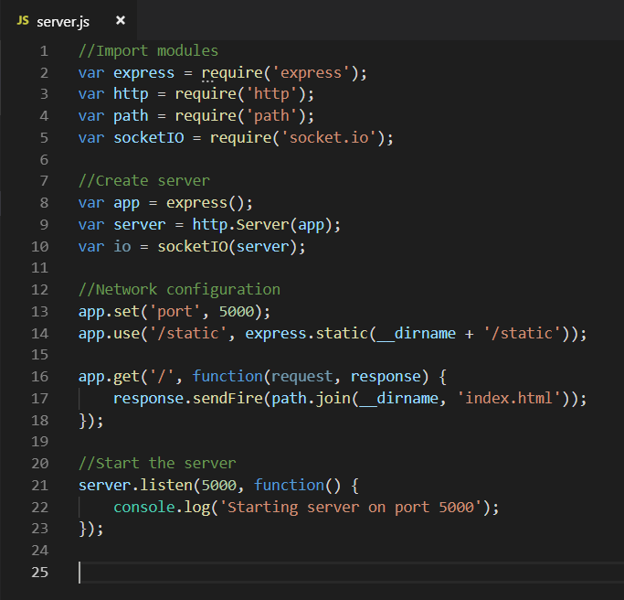
Let’s explain the individual components of this file:

Import modules:
These statements are how you import modules in Node. The modules are obtained from the node-modules folder. When we did the npm install command, the modules and all the modules they depend on were installed there. The modules consist entirely of Javascript code files. When we require a module, an object is returned that has all the methods and properties that the module made public.

Create server:
Now we call functions from the modules to create our server. App now contains a basic Express application. We create an http server from our app and then an io object is created to handle all the websockets. The point of using Express is that a bunch of stuff happens here that we don’t need to know about.

Network configuration:
Two things happen here. First, we set the port to 5000. Explain quickly how ports and IP addresses work
Then, we tell the server that it can serve static files from the Static folder. This means any static file (like a picture, a .js file, or a html file) that we put in that folder can be served to the client. You’ll see what that means in a moment.

Next, app.get routes a specific HTTP request to a specific callback function. What that means is that whenever someone accesses the root of the server, we send them the file index.html. __dirname just contains the name of the directory the server is running in, which we need in order to write the complete path.

Finally, we start the server on port 5000.

Now, we can run the server!
Run the following command in your project folder:
node server.js

You should see: Starting server on port 5000

If you go into your web browser and type into the address bar: localhost:5000, you will access your server by web page. However, you’ll see an error as it tries to serve index.html to you and fails because that file doesn’t exist yet. Let’s go create it!

Index.html
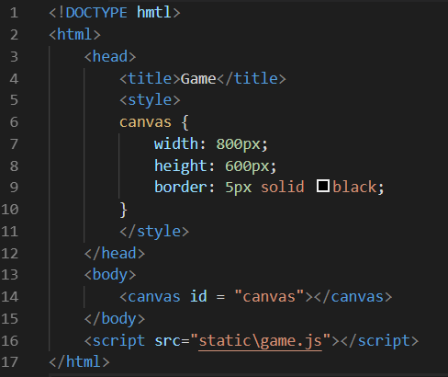

The html file is pretty standard. Our page only has a canvas element which we give a width, height and border. We also import a .js file which we will write soon.

